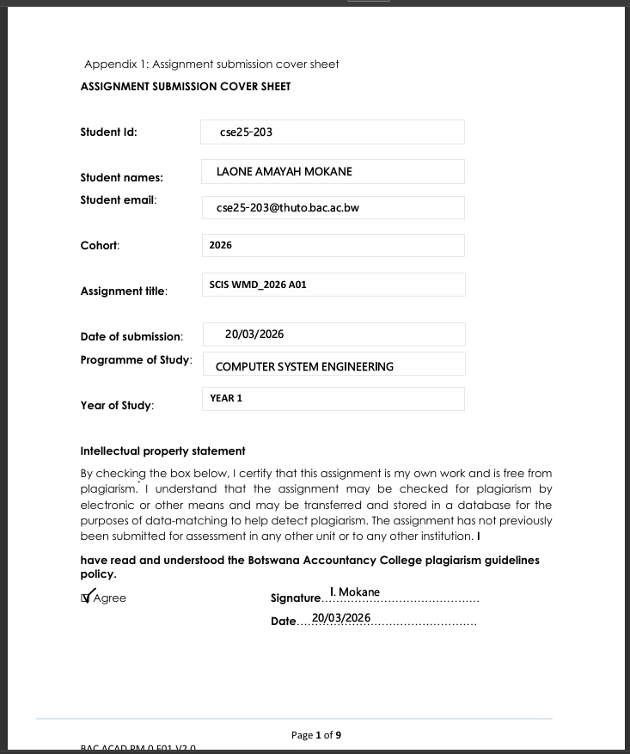

SECTION 1: WEBSITE SPECIFICATIONS
INTRODUCTION

StreamFlix is a web-based streaming platform that consolidates the most compelling features of two market-leading service, Netflix and Showmax into a single unified experience.

Netflix is a global web-based streaming platform recognised for its vast content library, personalised recommendations and seamless multi-device playback. Showmax is an African streaming platform operated by MultiChoice, recognised for its locally produced content and strong sports including the premier league and Dstv channels. It is also known for its affordability.

Therefore, StreamFlix merges both the cinematic and global depth of Netflix with the African relevance and sport live-streaming of Showmax resulting in a platform purposely built for the southern African market that delivers international blockbusters, original series, live sports and local content under one affordable subscription.

WEBSITE OBJECTIVES

The main objective of the SteamFlix website is to establish brand identity and credibility through consistent visual design and an intuitive navigation experience. Specifically, the site must:

- Attract and convert new visitors into paying subscription by clearly communicating the platform’s values, proposition, content breadth and competitive pricing.
- Provide a fully browsable catalogue of movies, series and live sports so prospective subscribers understand what they are playing for before committing.
- Offer a frictionless subscription pathway through a well-designed contact and sign-up form that captures user’s details and plan references.

WEBSITE GOALS

- Grow subscriber base
- Increase brand awareness
- Retain existing subscribers
- Launch StreamFlix originals
- Generate leads and feedback

TARGET AUDIENCE

- Primary audience

The core target audience is young adults consumers aged 18-30 living in the African continent. This demography has grown up with digital technology and its comfortable navigating streaming interface. They are employed or studying, have disposable income for a monthly subscription(BWP49-149), and consume media primarily on mobile phones and laptops. They expect fast-loading pages, intuitive navigation and visually engaging design comparable to global platforms they already use.

- Secondary audience

The secondary audience consist of families and households aged 25-50 seeking a combined entertainment package. Films for adukts, age-appropriate content for children and live sports. This group is more price-sensitive and values the ability to share a subscription across multiple screens(Standard and premium plans). They have moderate technical aptitude and appreciate clear labelling, large buttons an simple navigation.

TYPE OF WEBSITE AND CONTENT

StreamFlix is classified as a Commercial Entertainment Portal with the following characteristics:
SECTION 2: INFORMATION DESIGN AND TAXONOMY
Classification | Description
Website Type | Commercial Subscription Video On Demand (SVOD) Marketing and Preview site
Content Category | Entertainment- film, television series, live sports, original production
Interaction Model | Browse and Subscribe; user explore catalogue, select plan and submit sign up form
Content Volume | High- multi genres catalogues with hundreds of titles across five pages
Update frequency | Regularly- new titles, sports fixtures, promotions updated monthly
Monetisation | Subscription-based (Basic BWP 49, Standard BWP 100, Premium BWP 149

INFORMATION ARCHITECTURE

The information architecture follows three guiding principles drawn from web designs:

- The 3-Click Rule – any piece of content must be reachable within three clicks from the homepage
- Findability – genres, title and plans are grouped logically so users form accurate expectations of where to look.
- Consistency – the same navigation bar, footer and page structure appears on every page reducing the cognitive load on the visitors
SITE MAP

The site map below shows all the five pages, their sections and the connection between them. Every page is reachable directly from the persistent top navigation bar.

Homepage(index.html)

Provides the user with;
- Hero banner that shows the feature add to list and watch now
- A horizontal scroll showing 8 trend, StreamFlix originals, coming soon and Animation movies in a loop with a trailer when the cursor is pointed on the movie for a long time
- Pricing plans that show the three-tier subscription cards (Basic, Standard and Premium) for new subscribers
- A footer that shows the brand info, navigation links and social media icons

Movie.html
Provides user with various category to choose from(e.g. Sci-fi, Thriller, Horror..) showing this content at all available movies in a horizontal loop

Series.html
Provides user with various category and how many seasons and episodes each series has

Sports.html
Provides user with live matches of sports like football, basketball etc

Feedback.html
Provides user with our company’s contact information, a feedback form and a plan selection for existing subscribers
HOME
Index.html
-Persistent info
-Footer Links
-Social links
-Contact info
-HTML 5 form
-Plan selection
-Live banner
-Category card
-Fixtures Table
-Genre filter
-Series cards
- Season badge

SPORTS
Sports.html
SERIES
Series.html
MOVIES
Movies.html
-Genre Filter
-Catalogue Grid
-Play/Info overlay
ALL PAGES
CONTACT
Feedback.html

NAVIGATION PATH

The table below shows the navigation path a user takes to accomplish their goals ensuring the 3-click rule is satisfied

User goal | Navigation path | Clicks
Find a movie | HomeMoviesBrowse | 2
Find a series | HomeSeriesBrowse | 2
Watch live sport | HomeSportsLive Now/ Fixtures | 2
Subscribe | HomeClick Subscribe(nav)feedback form | 2
Contact support | HomeContact(nav)Fill form | 2
Find sport fixtures | HomesportsFixture table specific row | 3
Return Home | Any pageStreamFlix logo(nav) | 1

CONTENT CATEGORY AND TAXONOMY
SECTION 3: TECHNICAL BRIEF
Category | Tags used
Content type | Movies | Series | Live sports | Original | Documentary
Movie genres | Action | Drama | Comedy | Sci-fi | Horror | Thriller | Romance | Animation
Series genre | Crime | Fantasy | Drama | Comedy | Sci-fi | Thriller | Horror | Reality
Sports categories | Football | Basketball | Tennies | Cricket | MMA & Boxing | Formula 1
Quality tags | HD | Full HD | 4K | 4K+HDR
Status badges | NEW | Season number | LIVE
Audience Rating | PG | PG-13 | 16+ | 18+

This section documents all the technologies, software tools, graphic resorces and development standard used to design and build the StreamFlix website.

TECHNOLOGIES:

HTML 5 – This is where the building block of the website begins. Html 5 provides a structural layer of the web contents.
CSS3 – External Stylesheet – This is where the styling of the web happens. All the styling are contained in a single external file linked to all the pages
BOOTSTRAP 3 – A bootstrap is used to ensure that there is responsiveness across various screen sizes
JavaScript – It is used for form validation

DEVELOPMENT TOOLS:

Notepad++ it was used to create the html files and where the codes were typed
Git It’s a command line tool that tracked all the changes to the codebase
GitHub this is where the repository is created and managed and where all the website file are kept
GitHub Pages This is where deployment of the page branch takes place and make the website to be publicly accessed

GRAPHICAL TOOLS:

GIMP used to create, edit and export website images, logos and videos

TESTING TOOLS

The tools below were used to test the layout and functionality of the website across different devices;

-Goggle Chrome
-Microsoft
-Safari

